Work Group '06 Flows
The initial PRODML Work Group was focused on two use cases that were described in the PRODML Scope Statement document. One of these use cases includes gas lift optimization. Both use cases handle a combination of hydrocarbon products and deal with a variety of capacity and schedule constraints.
In consideration of the use cases and the need to organize the work effort into digestible units, the concept of a "Flow" was developed. These "Flows" (as in work "flows") focus on a subset of functionality, data, and constraints defined by the use cases. The flows are predicated on a requirement that once implemented, each flow would produce real value. A further consideration was that each successive flow would become increasingly complex. The following three flows were nominated and were then the subject of development effort.
Flow #1, #2 & #3 - Draft Documentation
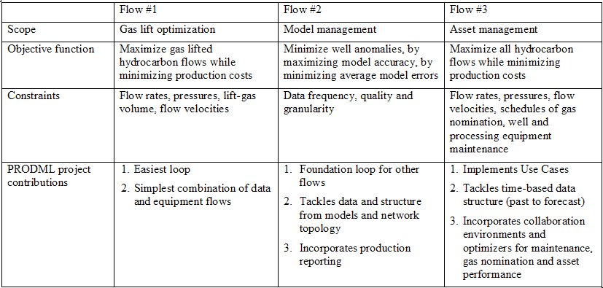
The various PRODML teams developed these three flows, where Flow #1 was more mature than Flow #2, etc. The following Project Outline Proposal documents were used to capture the emerging requirements of each flow. Taken together these three documents described the business side of the PRODML equation including what components of the network model would be touched, what application types were being considered, and the emerging minimum data requirements that would provide interoperability.
A complete picture of PRODML also required an understanding of the emerging Technical Requirement and Reference Architecture documents discussed under the Technical Requirements section of Project Execution.
The following documents are representative draft documents from 2006:
•Flow #1 Data Requirements - Project Outline Proposal
•Flow #2 Data Requirements - Project Outline Proposal
•Flow #3 Data Requirements - Project Outline Proposal
Excerpts from "Flow Documents"
The following three sections are excerpts from the linked documents above. They are presented here for the casual observer. Please review the actual documents for more detailed specifications.
•Flow 1 Excerpts
•Flow 2 Excerpts
•Flow 3 Excerpts
Flow #1 - Gas Lift Optimization
It was agreed that for the limited purposes of getting a proof-of-concept for Flow #1, its objective should be "gas lift optimization" in the sense of "the optimal allocation of gas to a number of wells given objectives and constraints." The term "gas lift optimization" is often used to mean the whole process of running a set of gas lifted wells in "the best way," including surveillance, design, etc. The team agreed that surveillance as a concept is dealt with in Flow #2, thereby keeping Flow #1 as simple as possible.
A proposed glossary entry for Real Time Gas Lift Optimization was drafted by Ron Cramer of Shell as follows:
Process whereby gas lift gas injection rate to each well is continuously adjusted to fulfill an objective function within given constraints. Objective function might be maximizing oil production from all wells using minimum volume of gas lift gas. Constraints might be:
•Using gas lift gas from a dedicated source
•Production capped at the available processing capacity of the surface well oil, gas and water facilities
•No changes to gas lift injection valves
•Unconstrained water production
•Economic considerations not taken into account
•Wells available for production
This is more or less what Flow #1 does on a simplified network, with the exception of the "available processing capability" which has been ignored, i.e. assumed to be uncapped, in this flow.
Approach - Network Model for Flow #1
The team worked using the simplified "black box" model of a network comprising flow units A to H that had been provided from earlier work. The diagram, updated with the current data points, is shown in Figure 1. The data points are listed in a table elsewhere in this document. Red are input data points and blue are output data points. Circular markers indicate the data point is at a port on a flow unit. Ribbon markers indicate that it is an internal attribute of a flow unit.
Flow #1 - Assumptions About Physical Nature of Units for Flow #1 Purposes
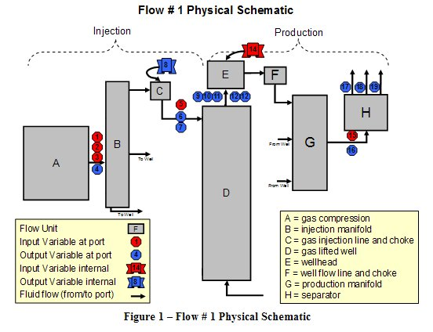
The team agreed that a greatly simplified model of the physical nature of the production system was appropriate in order to speed up the attainment of a proof-of-concept test. In particular, the following assumptions were made concerning the flow units:
Unit A. Gas Compression - assumed only one "effective compressor" to be present. In other words, if there are multiple compressors, Unit A will represent their composite performance and availability.
Unit B. Gas Injection Manifold - assumed only one to be present. Also, ignored hydraulics of this unit and its gas flow from Unit A. Thus, pressure at discharge port of Unit A is also pressure at discharge of Unit B. Unit B is acting only as a "junction."
Unit C. Gas Lift Controllers - assumed three to be present - one per well, Unit D.
Unit D. Gas Lifted Wells - assumed three to be present.
Unit E. Wellheads - assumed three to be present - one per well, Unit D. Assumed that these contain Block Valves so that the flow can be "on" or "off." Ignored pressure drops across this unit, except when set to "off."
Unit F. Flowline Chokes and Flowlines - assumed three to be present - one per well, Unit D. Assumed that these are "fully open" and not to be used to control back pressure and flow in Flow #1. Ignored pressure drop across these units.
Unit G. Production Manifold - assumed only one to be present. Also, ignored hydraulics of this unit and its production stream flow from Unit F and to Unit H. Thus, pressure at discharge port of Unit D (well) is also pressure at inlet port of Unit H (separator).
Unit H. Separator - assumed only one to be present. For the purposes of Flow #1, test separator line up will be dealt with by allowing the wells to be allocated a fixed amount of gas (see below). The physical line up to a different separator will not be included.
For more about Flow #1, read complete document: Flow #1 Data Requirements - Project Outline Proposal
Flow #2 - Model Management
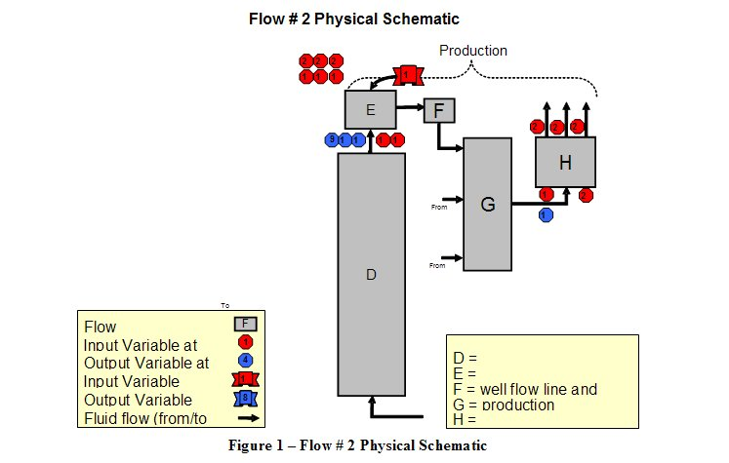
The objective of Flow #2 is to help oil and gas producers is to accelerate the localization of operations and information anomalies to within twenty minutes from more than 45 days, and thus maximize the usefulness of optimization mechanisms that are based on this flow. Models that reliably predict reality within an appropriate range of operating conditions are essential to a successful asset configuration determination. In the first phase of the process, models are expected to be properly calibrated. However, as time goes on, these models may no longer be adequate. The operating conditions may extend beyond the calibrated range of operating conditions or the physical reality may have changed: change in reservoir pressure, gas breakthrough, malfunctioning equipment -- these are a few possible causes. The purpose of the second flow is to address two aspects of this requirement:
•Validate the models against actual performance and
•Advise on what should be done in case of discrepancy between models and observed performance
The objective of this Flow is to minimize the average errors of the models. This is used to enable flows for well surveillance, production volumes, and asset optimization.
Approach - Network Model for Flow #2
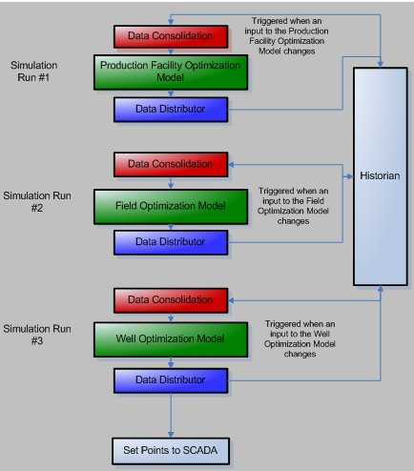
The team worked using the simplified "black box" model of a network comprising flow units A to H that had been provided by earlier work. The diagram, updated with current data points is shown in Figure 1. The data points are listed in a table elsewhere in this document. Red are input data points and blue are output data points. Circular markers indicate the data point is at a port on a flow unit. Ribbon markers indicate that it is an internal attribute of a flow unit.
Flow #2 - Assumptions About Physical Nature of Units for Flow #2 Purposes
For Flow #2, three models are required to simulate the 'what if' conditions. The three models are:
•Production Facilities Optimization Model
•Field Optimization Model
•Well Optimization Model
The use of simplifying assumptions will verify that the flow can be accomplished. It is intended that, as this initiative continues, these flows can be built upon, expanded, and made more realistic.
Two simplifying assumptions are made:
•Assumption 1: For the purposes of Flow #2, one point in time is used. At this point, the production and sales volumes are requested to change based on the ability to sell more gas and subsequently more oil. To further simplify the Flow #2 approach, the request for sales volume change, modeling for new conditions and physical changes in the field happen simultaneously. Flow #3 will deal with the complexity of time delays and staged changes over time. For example, Flow #2 will assume a single point of time, e.g. January 6th at 10:45 AM.
•Assumption 2: The results from the modeling perfectly simulates the conditions and provides accurate input parameters to allow optimal outputs. In other words, no consideration is being made for imperfections in the modeling, changes in well or operational performance or the time required to see the requested changes through the entire production system.
Data Flow Within Flow #2
It is important to realize that the computation associated with the flow network described above is calculated in multiple steps. Each simulator has a unique set of inputs. When a change in an input parameter is detected, the simulator runs with the new input parameters. The resultant output parameters are loaded into the Historian. This can trigger a secondary simulator run. An output for the first simulator can be input for a second causing another simulator run. The next paragraph explains the "general" Flow #2 data flow envisaged, whilst the second paragraph proposes a simplified proof-of-concept version of this data flow.
General Case. Figure 2 shows the envisaged flow of data. The red box is the Data Consolidator. It detects that a change in the Historian has occurred to an input parameter for a simulator and gathers the necessary data to be passed to the simulator. The blue box is the Data Distributor. It received the results from the simulator run and sends the information to the Historian. The Data Consolidator and Data Distributor may in fact be a single application that orchestrates the process.
In Figure 1, the Data Consolidator detects a change in input parameters to the Production Facility Optimization Model. For Flow #2, this input could be an increase in the Gas Volume and CO2 Volume acceptable to the Power Plant. The Data Consolidator would gather the necessary data from the Historian (assuming that all SCADA inputs are stored in the Historian) and passed to the simulator. When the first simulator, Production Facility Optimization Model, is run, the Data Distributor application would place the results in the Historian. These results would include the new Input Pressure to the Production Facility as well as the recommended total oil, gas, condensate, water, and CO2 production. This concludes Step 1.
The Data Consolidator application would detect new inputs for the Field Optimization Model. The Data Consolidator would gather the necessary information for the second simulator, Field Optimization Model. Upon completion of the simulator run, the Data Distributor would place the results in the Historian. These results would include the split of production rates between the various wells. With the Power Plant accepting more gas, the results of the Field Optimization Model run could indicate that a specific well be returned to production. This concludes Step 2.
The Data Consolidator application would detect new inputs for the Well Optimization Model. Many different well optimization models exist. The Data Consolidator would need to know which one to call for a specific well. The Data Consolidator would gather the necessary inputs to satisfy the appropriate Well Optimization Model for each well. The results from each run would be passed to the Data Distributor. The Data Distributor would place the results in the Historian. In addition, the Data Distributor would send the necessary 'set points' to the appropriate SCADA system.
For more about Flow #2, read complete document: Flow #2 Data Requirements - Project Outline Proposal
Flow #3 - Asset Management
The objective of Flow #3 is to help oil and gas producers adapt to schedules planned activity (export nominations, well activity and facility maintenance schedules) and forecasts of unplanned activity (flow assurance challenges, input data errors and changes in equipment performance), and thus maximize the usefulness of optimization mechanisms that are based on this flow.
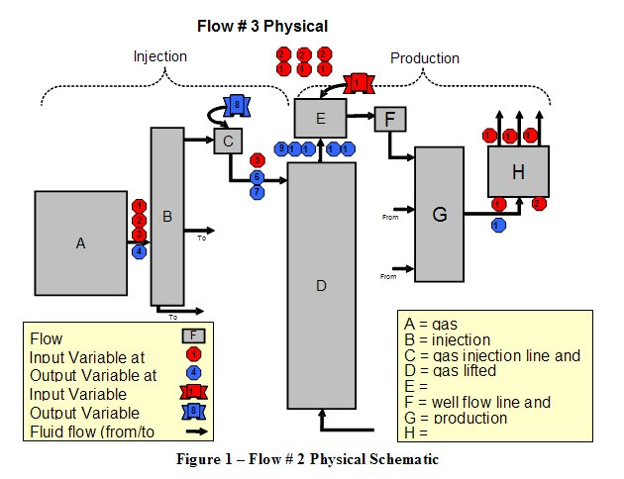
Optimizers that usefully guide production operations to adapt to changes in time (i.e. make changes early enough to compensate for the momentum of operations) are essential for production optimization.
The purpose of this third flow addresses two aspects of this need:
•Integrate time series so that applications can provide a series of modified targets and constraints to the optimizers, and
•Correctly represent multiple versions of key data such as wellhead component volumes.
The objective of this Flow is to maximize the performance of optimizers and model-based asset operations. This is used to enable flows for well surveillance, production volumes and asset optimisation. This flow is also used to fully meet the 2 Use Cases of the PRODML Work Group.
Approach - Network Model for Flow #3
The team worked using the simplified "black box" model of a network comprising flow units A to H which had been provided by earlier work. The diagram, updated with the current data points is shown in Figure 1. The data points are listed in a table elsewhere in this document. Red are input data points and blue output. Circular markers indicate the data point is at a port on a flow unit, ribbon markers indicate it is an internal attribute of the flow unit.
Flow #3 - Assumptions About Physical Nature of Units for Flow # 3 Purposes
For Flow #3, the models and applications defined for Flows 1 and 2 are used. There is a key enhancement that allows these to incorporate attribute dimensions. An optimizer can be adapted for time series as shown in the Figure 2.
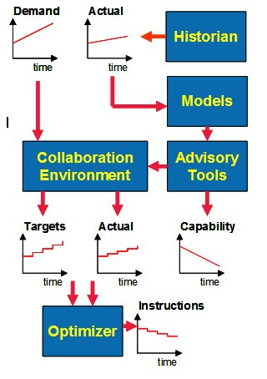
For more about Flow #3, read complete document: Flow #3 Data Requirements - Project Outline Proposal

